GRANDFIRE CLASSIC SERIES BBQs NATURAL GAS CONVERSION INSTRUCTIONS
(Change out kits for GF26, GF32LB, GF38LB)
TOOLS NEEDED
1. 6mm Box Wrench
2. 2 Adjustable Wrenches
3. Phillips Screwdriver
4. Small Flathead Screwdriver

PARTS IDENTIFICATION:
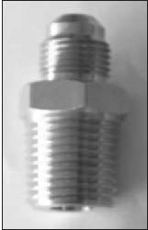
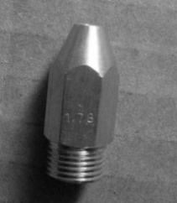
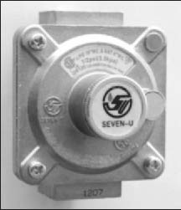
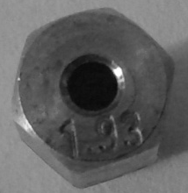

All Models
1/2 NPT x 5/8 Flare
Fitting (1 piece)
All Models
NG Regulator
(1 piece)
Rear Burner Orifice
NG-Φ 1.78mm
GF26 (0)
GF32LB (1piece)
GF38LB (1piece)
Main Burner Orifice
NG-Φ 1.93mm
GF26 (2pcs)
GF32LB (3pcs)
GF38LB (4pcs)

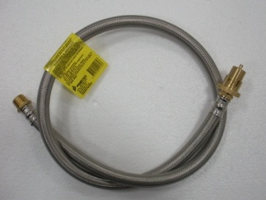
SS Braided Hose
DI=12mm, Bayonet Quick Connection,
All Models (1 piece)

OPTIONAL PART:
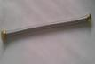
SS Flex Tube
L=420mm
(1 piece)

WARNING!
To prevent personal injury or damage to the grill, a licensed, authorized, service technician or contractor must perform the installation. Installation must be done in accordance with the installation instructions included with this product.

GRANDFIRE CLASSIC GRILLS NG CONVERSION INSTRUCTIONS
Step 1: (Change Main Burner Orifices) Remove all cooking grates and burner covers above. | Step 2: Unscrew the secure nut on the burner end. Lift burner end up and remove.
Step 3: Locate the valve with orifice in the hole on front basin. Use a 6mm box wrench to loosen LP orifice gently. | Step 4: Install NG orifices (Φ1.93mm) and gently tighten. DO NOT over tighten.
Step 5: Put main burner back and tighten the nut on the back. Make sure the orifice sits into the burner opening. | 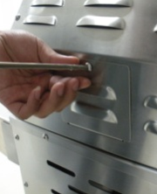  Step 6: (Change Rear Burner Orifice)  Remove the rear burner window on the back.
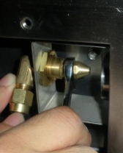  Step 7: Take out the LP orifice a wrench(Size: 10mm) . Replace the NG orifice on and tighten it. | Step 8: Put the rear burner window back into place.
Step 9: (Change Regulator) Remove the LP regulator and fitting with two wrenches. | Step 10: Install NG regulator with hose on and connect hose to bayonet point.
Step 11: (Fire Test/Low Flame Setting) Refer to User Manual fire test and low flame setting procedures.
* The SS flex tube is optional for longer connections from BBQ grill to NG regulator. It is not a must installed part.

Hauland PTY Limited.
Website: www. Grandfirebbqs.com.au
info@grandfirebbqs.com.au

